Create a Newspaper Article

Objective: Your task is to independently create a one-page (single spaced) newspaper article that focuses on an infectious disease topic discussed in class.
- Type all parts of the newspaper and put it together in a professional manner.
- Article must include:
  - Headline
  - Who, what, where, when, why, and how
  - Appropriate picture
  - At least two quotes from witnesses, doctors, nurses, scientists, or patients
- Edit your article (read it over and also have a classmate peer edit)
- Read the checklist provided before starting!
- Complete the “Reporter’s Notebook” worksheet provided to brainstorm your thoughts and ideas

Criteria | 3 | 2 | 1 | 0
One page newspaper article
Infectious disease topic is effectively discussed
Who (Ex. the organization/people)
What (Ex. what is happening?)
Where (Ex. where is the event/task occurring? )
When (Ex. when is this event/task happening?)
Why (Ex. why did the event/task occur?)
How (Ex. how did the event/task occur and how can it be treated/prevented?)
Powerful picture
Appropriate headline
Quotes are used within the article
Follows the inverted pyramid structure
Create a Newspaper Checklist

Total: /36

Formula for a Well-Written News Article

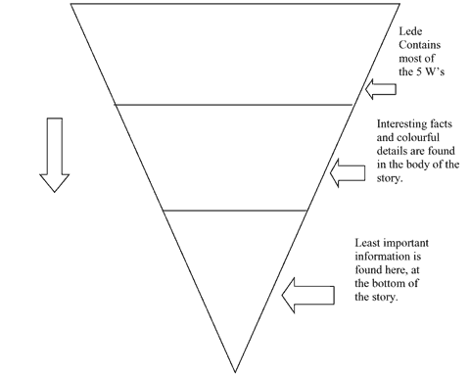
Articles in a newspaper are quick and to the point, not infused with a whole lot of personal opinion or evaluation, and tend towards the facts plain and simple as you can possibly imagine. All good newspaper articles start off with a good headline that will grab the reader’s attention and convince them to follow up and read the whole article. Most articles are written using the inverted pyramid to the right.

1. First paragraph
In your first one or two sentences tell who, what, when, where, and why. Try to hook the reader by beginning with a funny, clever, or surprising statement. Go for variety: try beginning your article with a question or a provocative statement.
2. Second/Third/Fourth paragraphs
Give the reader the details. Include one or two quotes from people you interviewed or something you read. Nothing brings people in like quotes. It will make your article more personable and give it a human quality, plus it allows you to break the flow of facts. Write in the third person (he, she, it, they). Be objective -- never state your opinion. Use quotes to express others' opinions!
There should be no more than three or four sentences per paragraph. If you have more to add about a particular topic, you should revisit it after a relevant quote.
3. Last paragraph
Wrap it up somehow (don't leave the reader hanging. Please don't say...."In conclusion" or "To finish..." Try ending with a quote or a catchy phrase.

4. The Picture
The last thing you need to know about how to write newspaper articles is that your article should contain a picture. Words are less powerful than a picture, and a captivating picture will make or break your readability. Without a picture, your article looks dry and unimportant. With a picture, you will suddenly gain notoriety and visibility.

